**CREATE IBM WATSON IOT PLATFORM AND DEVICE:**

1. To create the IBM Watson IOT platform and device

**STEPS:**

1. create an IBM cloud account with the individual IBM id and password

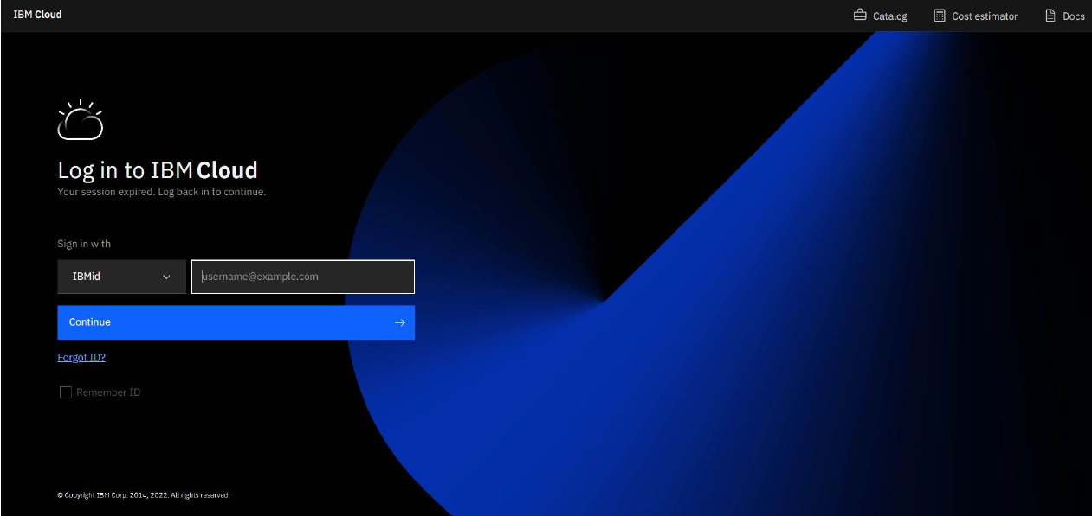

1. Home page of IBM cloud

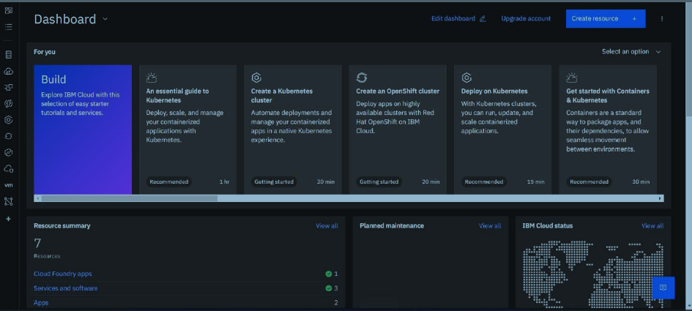

3.Click on the catalog on the top

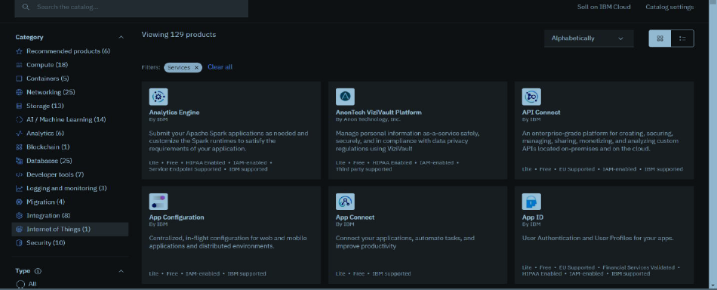

4.Click on IoT in the category mentioned

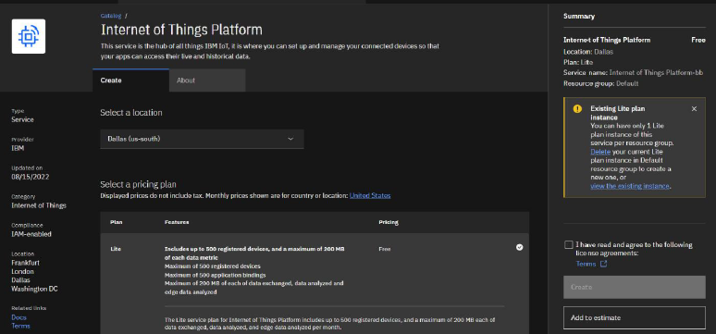

5.If already a lite is present delete it else u can’t create another

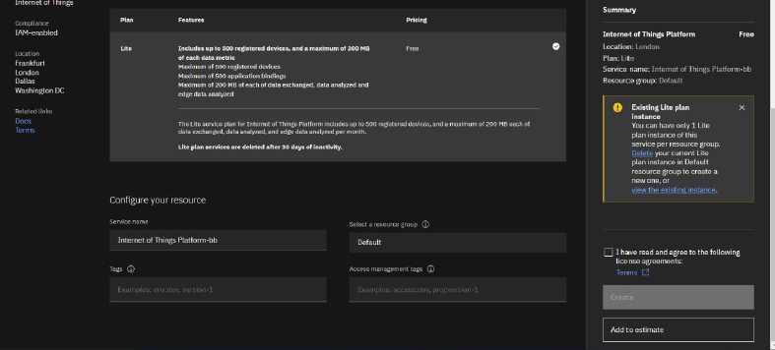

6. Enter the location and in the configure your resource type the service

name and choose the plan, tick the agree with agreements and then click

on create

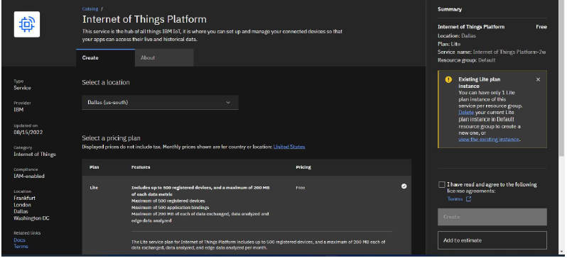

7. click create

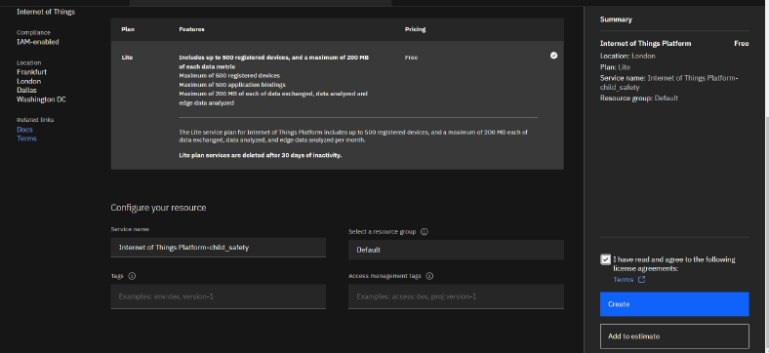

8.Internet of Things Platform Child_safety will be created

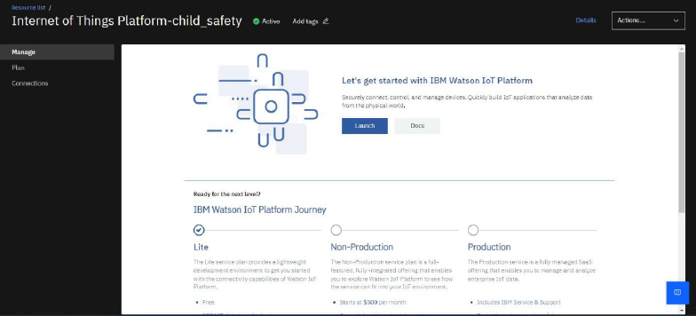

9.Manage is for launch, plan gives us the idea about the payment package

and its upgrades, and lastly the connection is for to connect IOT with

other services

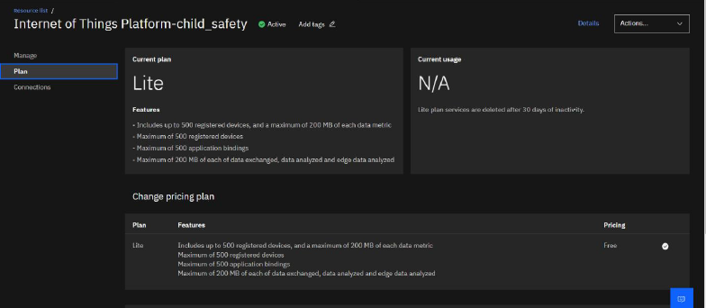

10. Click on the launch button in the manage tab, it will open to this

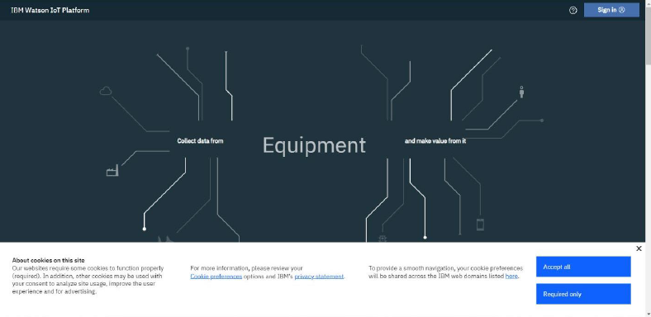

11.Enter the details to sign in to the Watson Cloud to create a device

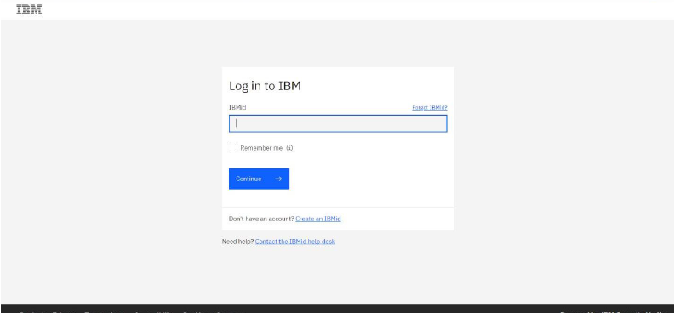

12.Once logged in the name will be displayed and it goes back to the first

Page

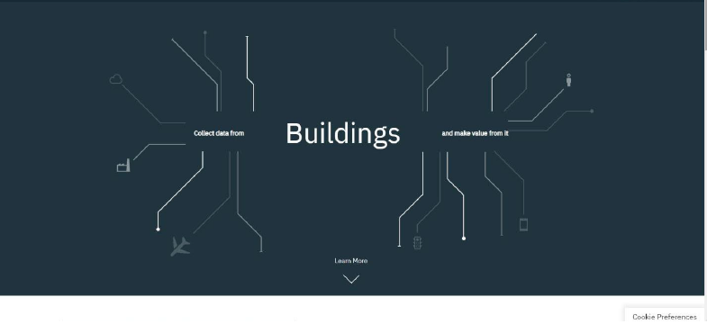

13. And again clicking on the launch button will open this tab, the

device will help in the creation of the devices, the addition of devices,

and the display of details of the devices.

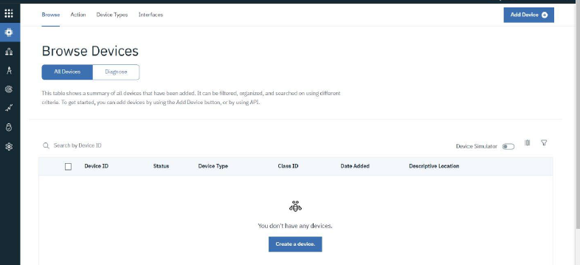

14.The setting tab is used to change the general setting if needed for the

project.

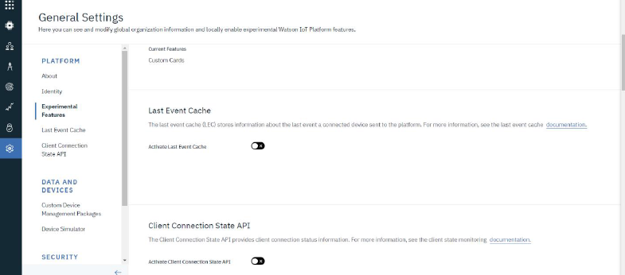

15.In the security tab we can choose the type of security connection and

can change according to specification

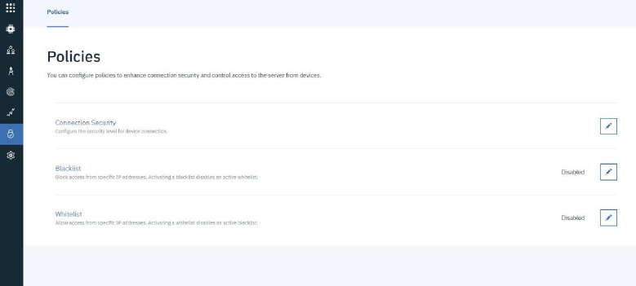

16. Usage gives the summary of how many bytes are used between the

devices and the IBM cloud

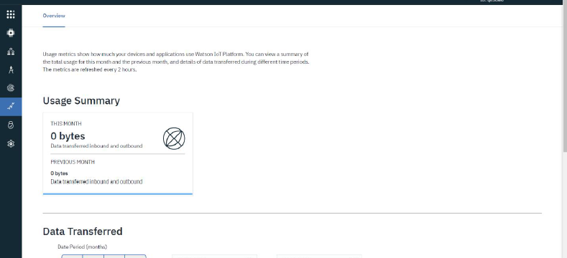

17. The member tab is add the teams members to work in the platform

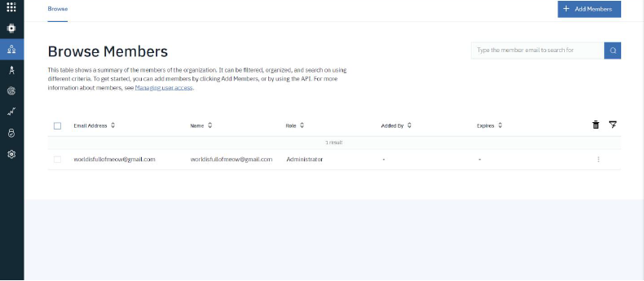

18. This tab is used when you want to connect to some other platform

and to integrate with other services.

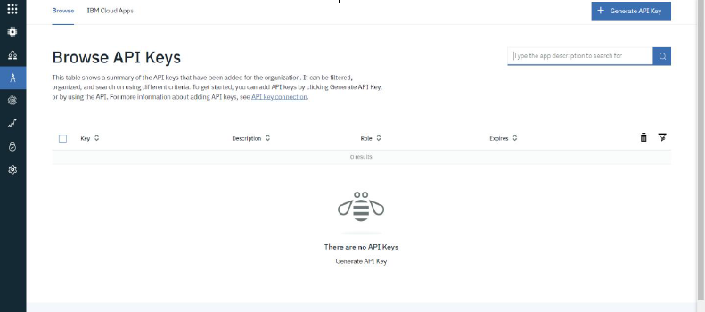

19. Click on the device tab and click on the add device button, then

give the device type and device id and click next

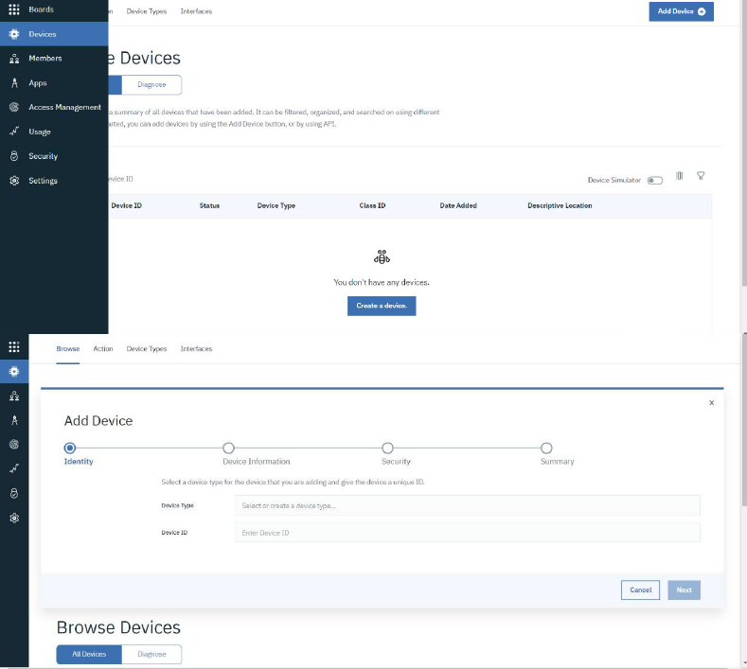

21. Clicking next it goes to the security where we do authentication

token id.

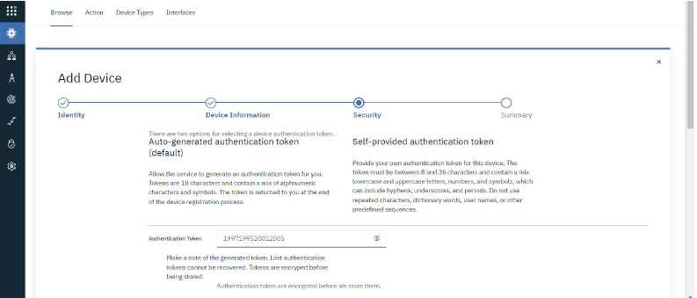

22. Clicking on next it goes to the summary of the device then click

Finish

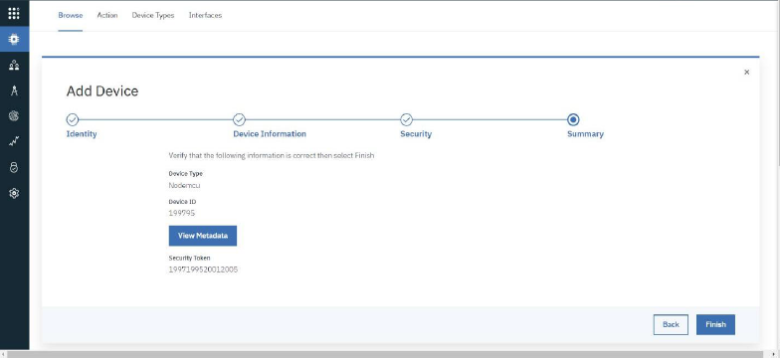

23. The device credentials will be displayed with all the details

24.Safe the details of the device as the authentication tokens are non

recoverable and if misplaced then we have to create a new one.

25.Clicking on the device tab we can now see the added device. Clicking

on it will display the other details. It has different tabs like Identity,

Device Information, State and login. In a similar way, we can create n number of devices with a 50 per page limit as per the requirement of our project

26. The Boards will display card for the project.

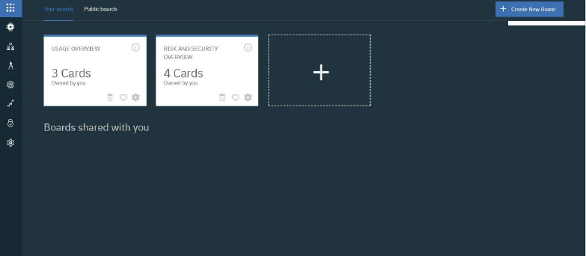

**CONCLUSION:**

An IBM Watson cloud for IoT and a device is created.